**Lab Assignment 2**

**Dataset Given**

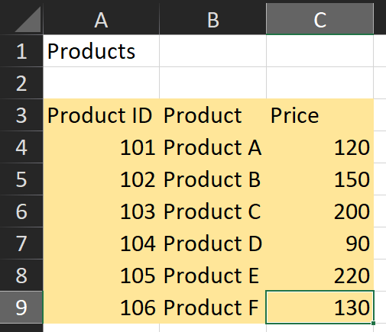

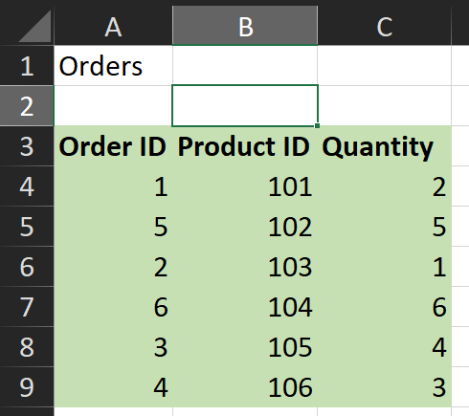

**Q1. Use VLOOKUP to find the product names for each ProductID in the Orders.**

**Ans.** Formula Used: =VLOOKUP(B4,Products!A3:C9,2,FALSE)

Output Obtained: Product Name

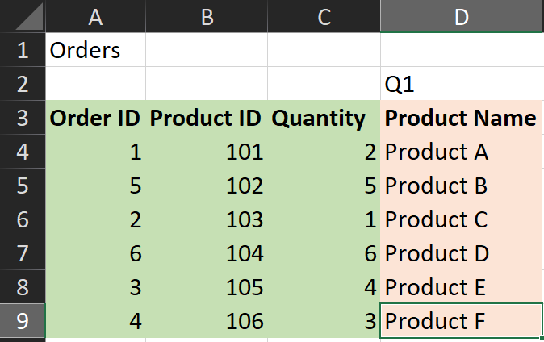

**Q2. Use VLOOKUP to find the price for each ProductID in the Orders worksheet, then calculate the TotalPrice by multiplying the Quantity by the Product Price.**

**Ans.** Formula Used: =VLOOKUP(B4,Products!A3:C9,3,FALSE)*C4

Output Obtained: Total Price

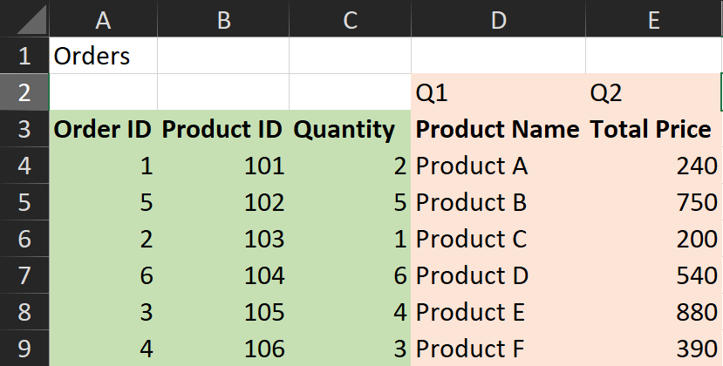

**Q3. Use VLOOKUP to check if there are any ProductIDs in the Orders worksheet that do not exist in the Products worksheet.**

**Ans.** Here, the basic approach would be to verify if the Product ID in the Orders Worksheet is equal to the Product ID in the Product Worksheet since Product ID is a primary key in both tables and a foreign key for Orders Table. If they don’t match then it means that it doesn’t exist. In our example, all of them exist surprisingly.

Formula Used: =IF(VLOOKUP(B4,Products!A3:C9,1,FALSE)=Orders1!B4,"Exists","Doesn't Exist")

Output Obtained: ID Exists?

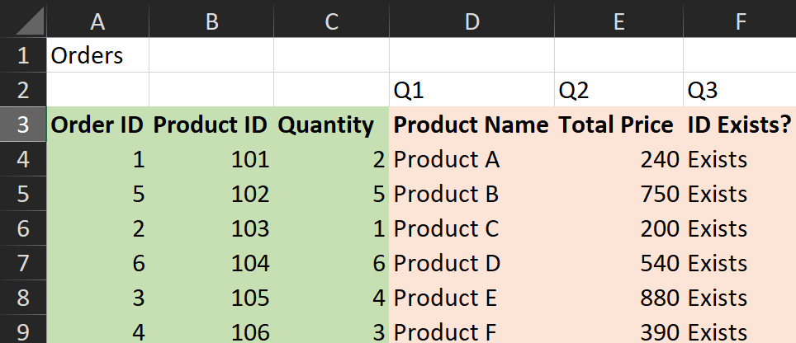

**Q4. Assume a discount of 10% is given on all products. Use VLOOKUP to find the original price and then calculate the discounted price.**

**Ans.** First, we find the Original Price using Vlookup function, then calculate the discount in another column for simplicity.

Formula Used: Original Price =VLOOKUP(B4,Products!A3:C10,3,FALSE) ;

Discounted Price =G4-(0.1*G4)

Output Obtained: Original Price, Discounted Price(10%)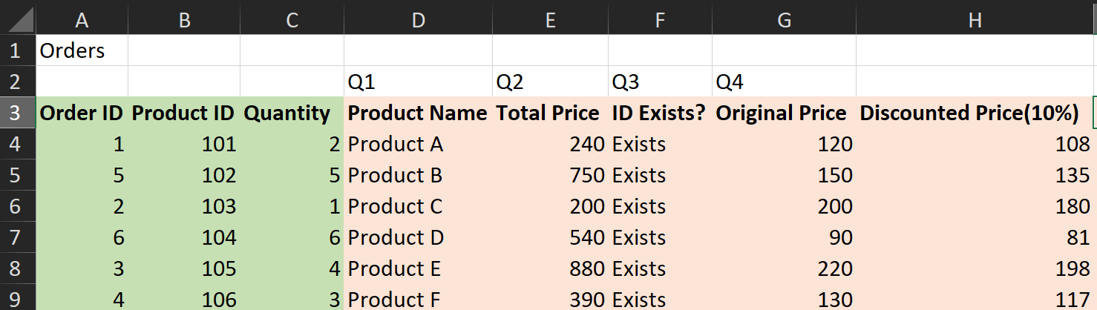

**Q5. Use VLOOKUP to find the price for each ProductID and then calculate the order**

**value. Find the maximum order value from the list.**

**Ans.** Assuming order value means the total order amount, we can do so by finding the price of each product using Vlookup function then multiplying it with the quantities.

Formula Used: =VLOOKUP(B4,Products!A3:C10,3,FALSE)*C4

For maximum: =MAX(I4:I9)

Output Obtained: Order Value

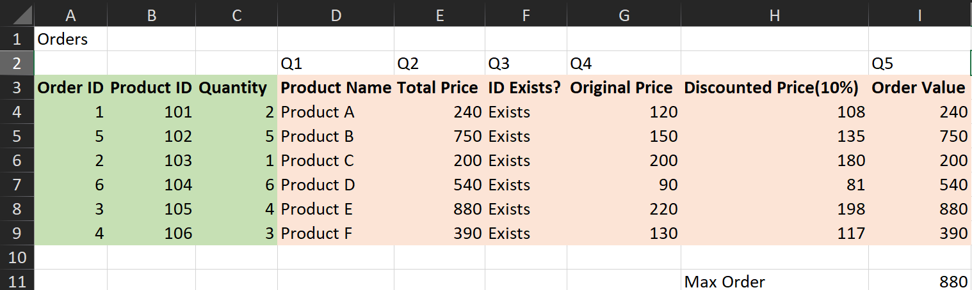

**Q6. Use VLOOKUP to find out which products from the Products worksheet have not been ordered.**

**Ans.** Here, we can simply check for the product ID in both the tables. If they match, then they must’ve ordered, otherwise they didn’t. In this case, all of them ordered.

Formula Used: =IF(VLOOKUP(B4,Products!A3:C10,1,FALSE)=Orders1!B4,"Ordered", "Not Ordered")

Output Obtained: Ordered?

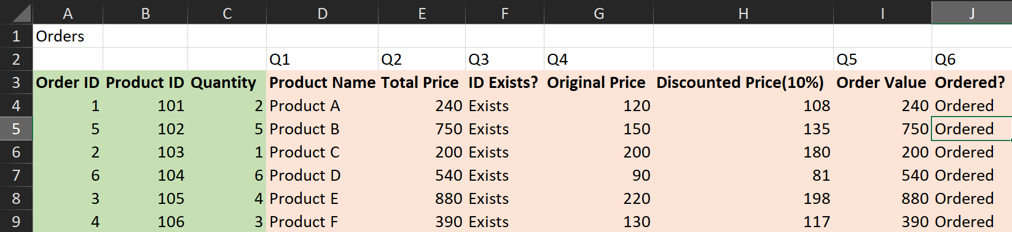

**Q7. Use VLOOKUP to find the Product name and summarize the total quantity sold**

**for each product.**

**Ans.** Here, we fetch the product names based on the product ID using Vlookup function again. Quantities of these products were already provided to us in the dataset. Therefore, to visually summarize the quantities sold for each product, we can create a bar graph.

Formula Used: =VLOOKUP(B4,Products!A3:C10,2,FALSE)

Output Obtained: Product Name, Quantity Sold

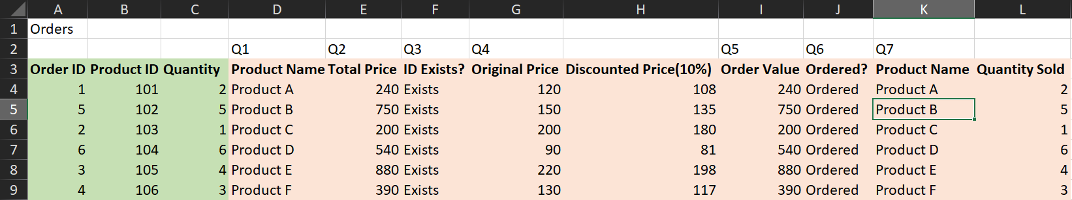

Corresponding graph plotted between Quantities and Products